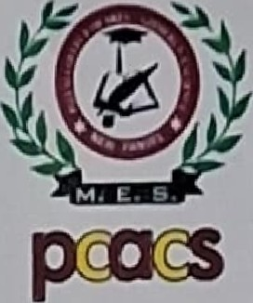

Mahatma Education Society's
Pillai College of Arts, Commerce & Science
(Autonomous)
Affiliated to University of Mumbai
NAAC Accredited 'A' grade (3 cycles)
Best College Award by University ofMumbai
ISO 9001 :2015 Certified
6th March, 2026
To,
The Officer In-charge
Summer Training Programme 2026, ICMR-NIRRH, Parel, Mumbai.
Subject: Recommendation letter for Summer Training Programme 2026 at NIRRH
Dear Sir/Madam,
I am pleased to recommend our M.Sc, Biotechnology student for the Summer Training Programme at the National Institute for Research in Reproductive and Child Health (NIRRH)
The student will be completing M.Sc. Biotechnology Semester Il in April 2026 and is keen to undergo a two-month training programme at your esteemed institute from 25th April 2026 to 24th June 2026.
Student Name | Roll Number | Admission Number
Mr. Arhant Arun Kushalvardhan | 3309 | 2025PC1482
He is a sincere and hardworking student with a strong interest in scientific research. I am confident that exposure to the research environment at your institute will greatly enhance his knowledge, technical skills, and overall academic development.
This training opportunity will be highly beneficial for his future career, and I sincerely request you to kindly consider his application. His resume is attached herewith for your kind perusal.
Thank you for your time and consideration.
Regards,

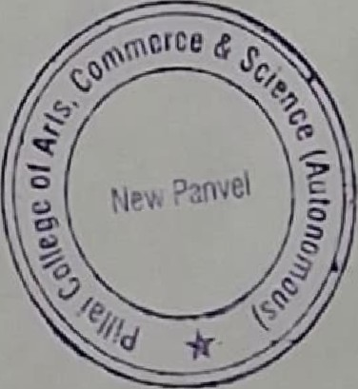
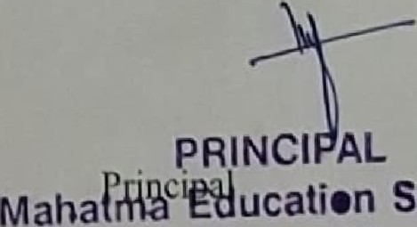Society's
Pillal College of Arts, Commerce & Science (AlJtoncmus)
Affiliated to University of Mumbai
Dr K. M. Vasudevan Pfllai Campus. Sector-16. New Panvel -410 206.
Dr: K•.M. Vasudevan Pillai Campus, Sector 16, New Panvel - 410206.
Tel:2745 6100 / 1700 Fax: 2748 3208. Website: www.pcacs.ac.in

